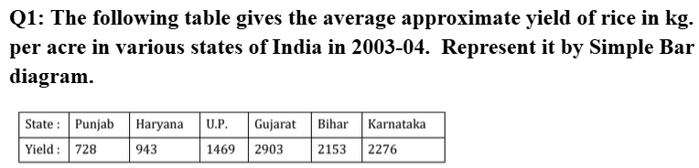
COMMAND:
x=c("Punjab", "Haryana", "U.P.", "Gujarat", "Bihar", "Karnataka")
y=c(728, 943, 1469, 2903, 2153, 2276)
barplot(y, names.arg = x, col = "red", border = "blue", main = "Yield of rice in kg. per acre in various states of India", xlab = "States", ylab = "Yield")
OUTPUT:
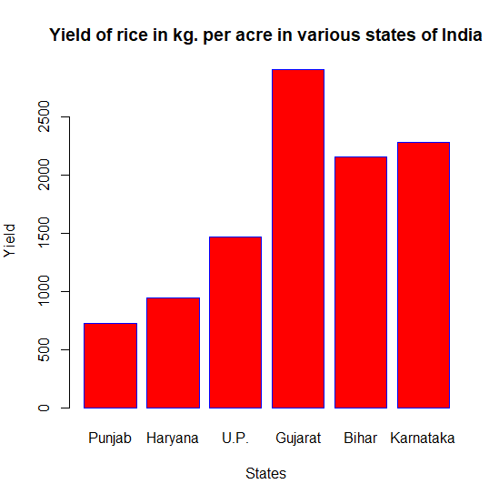
==============================================================================

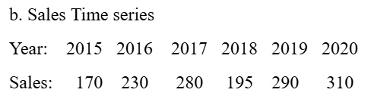
COMMAND:
x=c(2015:2020)
y=c(170,230,280,195,290,310)
barplot(y, names.arg = x, col = "blue", border = "black", main = "Sales time series", xlab = "sales", ylab = "year")
OUTPUT:
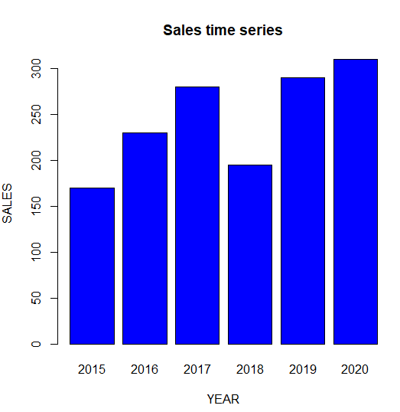
==============================================================================
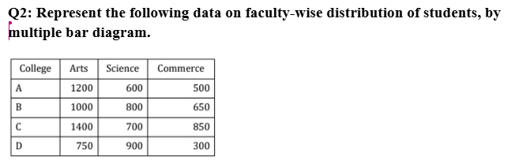
COMMAND:
clg=c("A", "B", "C", "D")
clgA=c(1200,600,500)
clgB=c(1000,800,650)
clgC=c(1400,700,850)
clgD=c(750,900,300)
d=data.frame(clgA,clgB,clgC,clgD)
d1=as.matrix(d)
d1
barplot(d1, beside = T, names.arg = clg, col =c("blue","red","green"),legend = c("Arts","Science", "Commerce"),xlab = "College", ylab = "No. of Students",main="Multiple Bar diagram”)
OUTPUT:
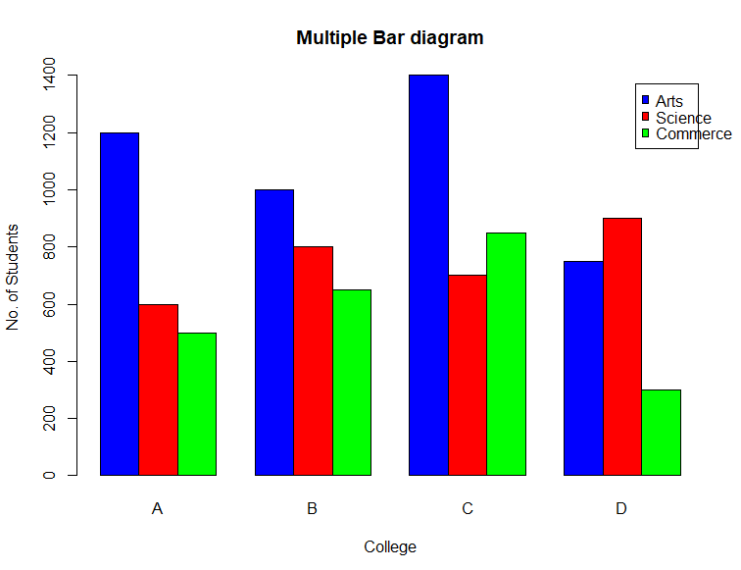

SUBDIVIDED:
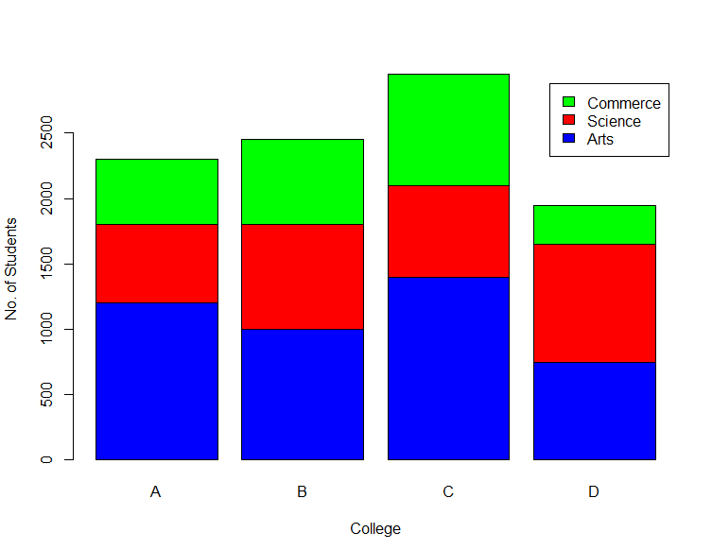
==============================================================================
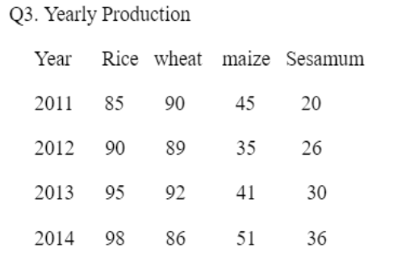
COMMAND:
year=2011:2014
a=c(85,90,45,20)
b=c(90,89,35,26)
c=c(95,92,41,30)
d=c(98,86,51,36)
D=data.frame(a,b,c,d)
D1=as.matrix(D)
D1
barplot(D1, beside = TRUE, names.arg = year, col =c("blue","red","green","yellow"),legend = c("Rice","Wheat","Maize","Sesamum"),xlab = "Year", ylab ="Yearly Production")
OUTPUT:
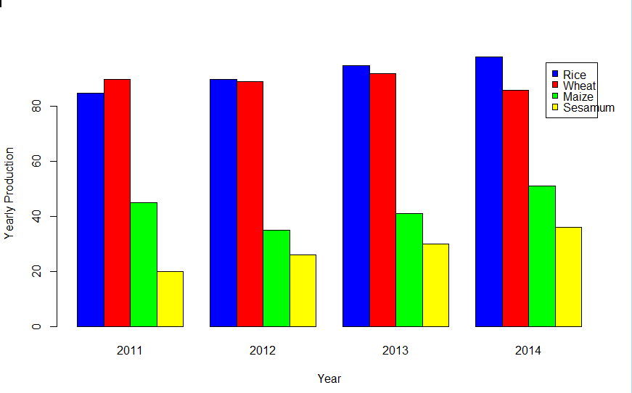
============================================================================== 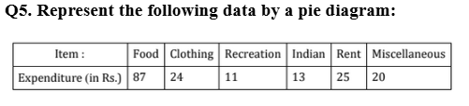
COMMAND:
x=c("Food", "Clothing", "Recreation", "Indian", "Rent", "Misc")
y= c(87, 24, 11, 13, 25, 20)
pie(y, main = "Expenditure", labels = x, radius = 1,col= rainbow(length(y)))
OUTPUT:
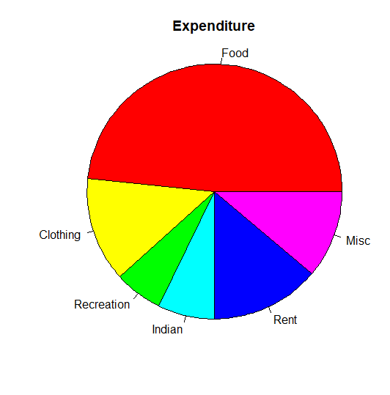
==============================================================================
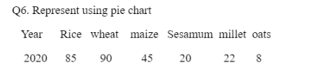
COMMAND:
x=c("RICE", "WHEAT", "MAIZE", "SESAMUM", "MILLET", "OATS")
y= c(85,90,45,20,22,8)
pie(y, main = "Expenditure", labels = x, radius = 1,col= rainbow(length(y)))
OUTPUT:
